 **PROMO VIDEO MAKING FOR**

**DIGITAL MARKETING**

## A PROJECT REPORT

***Submitted by***

# TEAM ID: NM2023TMID06759

# JEYASRI.K (Reg no:912620106004)

# SHENBAGAHARINI.V (Reg no:912620106006)

# ARTHI.S (Reg no:912620106003)

# ABITHA.S (Reg no:912620106301)

***In partial fulfillment for the award of the degree***

***Of***

# BACHELOR OF ENGINEERING

**IN**

## ELECTRONICS AND COMMUNICATION ENGINEERING

**SRI BHARATHI ENGINEERING COLLEGE FOR WOMEN KAIKURICHI,PUDUKKOTTAI-622 303**

## ANNA UNIVERSITY:CHENNAI 600 025

**OCT 2023**

ANNA UNIVERSITY: CHENNAI 600 025

# BONAFIDE CERTIFICATE

Certified that this Project report **“PROMO VIDEO MAKING FOR DIGITAL MARKETING”** is bonafide work of **JEYASRI.K (Reg.No 912620106004),** **SHENBAGAHARINI.V (Reg.No912620106006)**, **ABITHA.S**

## (Reg.No 912620106301), ARTHI.S (Reg.No 912620106003), who carried out

the project work under my supervision.

**SIGNATURE OF SIGNATURE OF**

**MENTOR EVALUATOR**

**SIGNATURE OF SIGNATURE OF**

**SPOC HEAD OF THE DEPARTMENT**

**PROMO VIDEO IN DIGITAL MARKETING**

**Introduction**

A promotional video is a business video with the intent to promote your products and services to customers and prospects.

A good promo video seeks to bring the conversation to a more personal level without making the sales aspect so overt. Any video you create is in some sense attempting to sell your brand to your target audience. However, that doesn’t mean it’s a blatant sales pitch.

You’ve no doubt seen companies release videos in the past which celebrate an achievement or event, wish viewers a happy holiday, or tell their brand story. These pieces of content are promotional videos. They’re transmitting information from the brand to the audience but without outright asking you to buy something.

If it helps, think of it this way: every video ad is a promotional video. Not every promotional video is a video ad. Diving into digital marketing can be like opening up a digital can of worms. For many, it can be intimidating. You know what, though? It doesn’t have to be. Understanding the role which videos will play in your strategy can ease some of that intimidation. It helps to get you and your team on the same page. A good jumping-off point is to properly define just promotional video is. There are many types of videos you can produce for your business. From product videos and testimonials; to explainer and employee training videos.

But, let’s make sure you understand the proper promotional video definition first!

**Types of Promo Videos**

When it comes to the kinds of promo videos you can create, you have a world of options.

* Product videos
* Intro videos
* Product launch videos
* Event videos
* Explainer videos
* Video ads
* Recruitment videos
* FAQ videos
* Testimonial videos

… and more. There are quite a few possibilities when it comes to creating, so don’t be afraid to think outside the box and get inspired.

**How to make promotion video?**

Now that we’ve gone over a promotional video definition and its relation to potential sales, you should understand how simple it is to create one.

Promo.com is a video creation platform that specializes in brilliant video templates that will really take you to the next level when it comes to making a promotional video. With more than 15 million premium video clips, thousands of professionally licensed music tracks, easy Facebook integration, and a lifetime license, this is the type of platform that will change the way you do video marketing.

**Steps to make a promo video:**

1. Script it out.
2. Storyboard your vision.
3. Produce your video.
4. Assemble your video edit.
5. Promote your promo video.

Ready for more detail? Let’s take a closer look at each step.

Start with the most basic concept: what are you promoting? Next, come up with a playful concept: what’s your angle on this promotion? Is it holiday-themed? Are you urgently corresponding about a pain point your viewer regularly faces? Or if it’s an event, how can you get creative around the theme of the event?

Focus on keywords and key concepts you want to use in your promo video. What are three or four of the key takeaways you want your audience to remember about this promotion? For example, if you’re doing a short business promo video, you might want to focus on a few core values you want your audience to connect with, like in this example:

Keep your script short – promos can be up to a minute or minute and a half, but we don’t advise that. Thirty seconds and under are the sweet spot, especially if the promotion is pretty straightforward. Event promos can go longer, but again, we don’t recommend going over a minute if you can help it.

A lot of the time, promo videos will require visual aids like graphics or title cards, so make sure to plan those out in advance using a **storyboard**. Even if you’re going to be promoting an upcoming sale and want to show off your storefront or products in a **montage format**, you should try and map out what all you want to feature. The more you plan ahead, the easier it is when you show up to set and film!

In the case of an event promo, you might be using footage from a previous event to promote an upcoming one. If that’s the case, you can still plan what key elements of your past event you’re looking to feature to make the assembly easier on your editor!

There are also opportunities to create multiple versions of the same promo video. Try coming up with a few short variations on the same theme or idea, so you can create multiple promo videos for the same promotion. But remember to keep them simple so you can shoot them all at the same time!

You’ve scripted and story boarded your vision, so now it’s time to produce the video! Depending on your goal, shooting on location in your store, office, or event location is the best way to go.

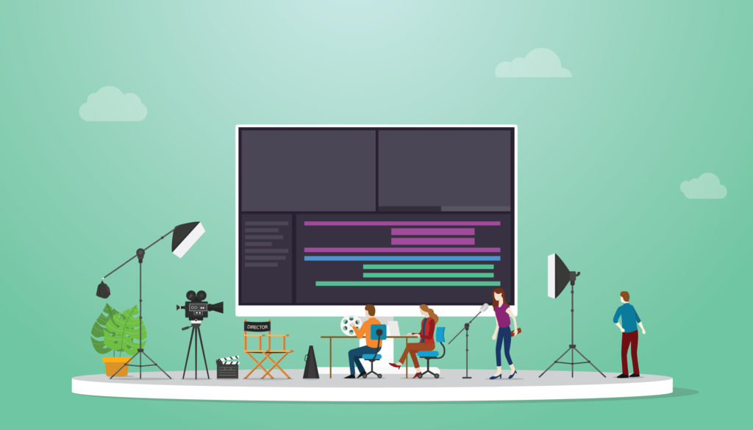

If your promo video includes an abstract or short narrative concept, you’ll want to secure those locations in advance. For example, for an abstract promo video, you might want to use a studio space with a totally white background, so all the emphasis is on your unique and exciting product.

### **Once you’ve filmed your video, it’s time to put it together. This is also referred to as the [post-production stage](https://www.lemonlight.com/blog/7-things-you-need-to-know-about-video-post-production/); if you don’t know much about post-production, check out that link for a full breakdown.**

One of the most critical elements in a promo video is sharing vital information, like discount codes, dates and times for events, or deadlines for the end of a sale. Make sure you include that information visually with graphics and title cards so your audience doesn’t miss out!

Graphics help add and highlight key information, and can be used in all sorts of creative ways. It’s always best to plan ahead when it comes to graphics, so coordinate them accordingly by baking them into your storyboard for maximum efficiency.

Check out how we used graphics creatively in this promo we created for one of our own marketing initiatives!

Now that your video is done, it’s time to promote it! The goal of a promo is to get the word out, so try some of the following techniques to get your promo video seen:

**[Social](https://www.lemonlight.com/blog/5-ways-to-drive-your-digital-marketing-strategy-with-social-video/):** Your social channels are one of your company’s key owned audiences, so definitely push out your promo video (or *videos*) on your social media feeds!

**[Email](https://www.lemonlight.com/blog/best-practices-when-using-video-for-email-marketing/):** Just like you would send multiple emails to promote an event or discount promotion, you’ll want to email your subscribers (multiple times) with your promo video in newsletters and e-blasts so they remember to take advantage before it’s too late.

**[Paid Ads](https://www.lemonlight.com/blog/paid-video-distribution/):** Put some spend behind your promo video to get it seen on social media, and use retargeting ads to **retarget your followers** and subscribers who have opened your promotional email so they’re reminded of the promotion!

**[Website](https://www.lemonlight.com/blog/5-fun-and-effective-ways-to-incorporate-video-onto-your-website/):** When promoting a time-sensitive promotion, you don’t want to miss any opportunity to engage potential customers, so post your promo video on your website and company blog, too!

**Benefits of video promotion:**

Video advertising is in trend. The statistics show that the customers are watching more video, that is the most significant advantage. Around 4 billion videos are being watched on YouTube on daily basis and almost one-third of audience will buy a product after viewing a video promotion.

ii.                  Increase in sales. The giants of online shopping platforms like eBay and Amazon, show that embedding a video promotion to a product detail raise the prospects of a user purchasing that product by more than 35 percent.

iii.                Videos are being shared. People who watch a video promotion and find it appealing or important will share it with their connections on social media sites. Over 700 videos are being shared by Twitter alone in a minute. This tells us that the video promotion can offer you a huge benefit of expanded exposure within minutes.

iv.                Video promotions perform well among mobile users. One of the biggest audience of promotional videos is mobile users. Around 88 percent of short videos that businesses share are watched through mobile devices, unlike PCs.

v.                  Video is an effective and brilliant form of educating. Since it integrates visual and audio components that attract diverse senses of a person, video promotions are also excellent medium for education. They are particularly efficient when used for product show reel or guides, since audience can see how specific things can work.

vi.                Videos have a good rating at search engines. The search engines place a preference on video material when twisting their algorithms that offer specific sites higher on the result pages. Sharing videos through social media, placing them on blog posts and integrating them on your website augments the potential that your target market will find you when looking for pertinent details.

If these benefits of promotional video didn’t encourage you to get started, here’s one more huge reason to get tract: your rival is sharing videos and grabbing the attention of your prospect clients.

**DEMO LINK:**

[https://www.canva.com/design/DAFyWXBbE1M/dMNYAfMydD3Nzqr0kV9G9g/edit?utm\_content=DAFyWXBbE1M&utm\_campaign=designshare&utm\_medium=link2&utm\_source=sharebutton](https://www.canva.com/design/DAFyWXBbE1M/dMNYAfMydD3Nzqr0kV9G9g/edit?utm_content=DAFyWXBbE1M&utm_campaign=designshare&utm_medium=link2&utm_source=sharebutton" \t "https://mail.google.com/mail/u/0/" \l "inbox/_blank)

**BRAND LOGO:**



BRAND PROMO:

[https://www.canva.com/design/DAFyWXBbE1M/dMNYAfMydD3Nzqr0kV9G9g/edit?utm\_content=DAFyWXBbE1M&utm\_campaign=designshare&utm\_medium=link2&utm\_source=sharebutton](https://www.canva.com/design/DAFyWXBbE1M/dMNYAfMydD3Nzqr0kV9G9g/edit?utm_content=DAFyWXBbE1M&utm_campaign=designshare&utm_medium=link2&utm_source=sharebutton" \t "https://mail.google.com/mail/u/0/" \l "inbox/_blank)

BRAINSTROME &EMPATHY MAP:

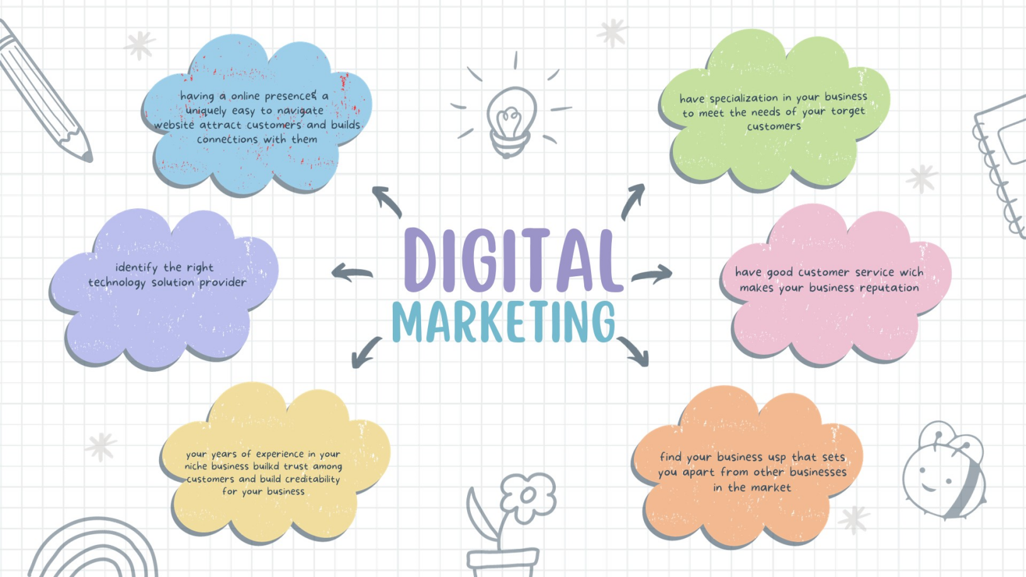

**ADVERTISEMENT:**

[https://youtube.com/shorts/ukppDqwFlXE?si=Kg1L8HCBZiBYyfDI](https://youtube.com/shorts/ukppDqwFlXE?si=Kg1L8HCBZiBYyfDI" \t "https://mail.google.com/mail/u/0/" \l "inbox/_blank)

**SOCIAL MEDIA REEL:**

[https://youtu.be/HUcjWcR07\_8?si=02lxF\_2iGwzfsHr9](https://youtu.be/HUcjWcR07_8?si=02lxF_2iGwzfsHr9" \t "https://mail.google.com/mail/u/0/" \l "inbox/_blank)

**Conclusion:**

Promo videos are effective primarily because consumers are humans and humans are largely driven by emotion. Sure, we like to think that we make decisions based on logic, but in reality, our emotions are what happen to us first. If you can touch a consumer on an emotional level, you've hooked them. That's what promotional videos are great at doing: plucking heartstrings. Once they've been plucked, you can seal the deal with science (the benefits and features). First, you need to connect with them emotionally. There's really no better marketing channel to do that than video.